**NRF controlled robot car using joystick**

**Introduction**

In this project we will make a car remotely controlled with Arduino nano, L298N, NRF24L01 and joystick. The car is controlled by a joystick and the module NRF24L01 sends values to the receiver located in the car. The speed of the motors is controlled proportionally. The motors are controlled by the L298N module and powered by six AA (R6) batteries. The NRF24 master library is required to operate the NRF24L01 module.

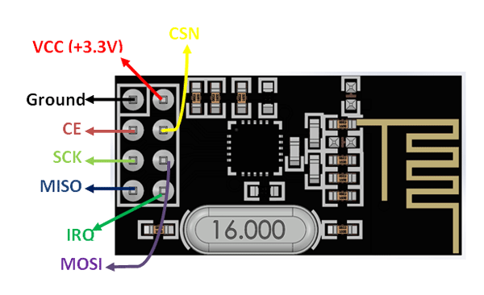**Components**

* Arduino nano(2)
* NRF24L01(2)
* L298D motor driver ic
* Joystick module
* Motor
* Battery and battery holder
* Switch
* Breadboard & connecting wires

NRF24L01 module.

**Application**

* Used in wireless remote control
* Used in wireless data transfer

**Objective**

During this activity ,you will help students to achieve following objectives

1. Understanding the principle and operation of NRF24L01 RF module
2. Design algorithm and flowchart to control robot car using joystick
3. Programming NRF24L01 RF module using Arduino nano
4. Interfacing NRF24L01 RF module with Arduino nano

**Program**

**Transmitter code :**

#include <SPI.h>

#include <nRF24L01.h>

#include <RF24.h>

RF24 radio(8,9); // CE, CSN

const byte address[6] = "00001";

char xyData[32] = "";

int joystick[2];

void setup() {

Serial.begin(9600);

radio.begin();

radio.openWritingPipe(address);

radio.setPALevel(RF24_PA_MAX);

radio.stopListening();

}

void loop() {

joystick[0] = analogRead(A4);

joystick[1] = analogRead(A3);

radio.write( joystick, sizeof(joystick) );

}

**Receiver code :**

#include <SPI.h>

#include <nRF24L01.h>

#include <RF24.h>

#define enA 6

#define in1 7

#define in2 5

#define enB 3

#define in3 4

#define in4 2

RF24 radio(8,9); // CE, CSN

const byte address[6] = "00001";

char receivedData[32] = "";

int xAxis, yAxis;

int motorSpeedA = 0;

int motorSpeedB = 0;

int joystick[2];

void setup() {

pinMode(enA, OUTPUT);

pinMode(enB, OUTPUT);

pinMode(in1, OUTPUT);

pinMode(in2, OUTPUT);

pinMode(in3, OUTPUT);

pinMode(in4, OUTPUT);

Serial.begin(9600);

radio.begin();

radio.openReadingPipe(0, address);

radio.setPALevel(RF24_PA_MAX);

radio.startListening();

digitalWrite(in1, LOW);

digitalWrite(in2, LOW);

digitalWrite(in3, HIGH);

digitalWrite(in4, LOW);

}

void loop() {

if (radio.available()) { // If the NRF240L01 module received data

radio.read( joystick, sizeof(joystick) );

radio.read(&receivedData, sizeof(receivedData));

yAxis = joystick[0];

xAxis = joystick[1];

Serial.println(yAxis);

Serial.println(xAxis);

}

if (yAxis < 470) {

digitalWrite(in1, HIGH);

digitalWrite(in2, LOW);

digitalWrite(in3, HIGH);

digitalWrite(in4, LOW);

motorSpeedA = map(yAxis, 470, 0, 0, 255);

motorSpeedB = map(yAxis, 470, 0, 0, 255);

}

else if (yAxis > 550) {

digitalWrite(in1, LOW);

digitalWrite(in2, HIGH);

digitalWrite(in3, LOW);

digitalWrite(in4, HIGH);

motorSpeedA = map(yAxis, 550, 1023, 0, 255);

motorSpeedB = map(yAxis, 550, 1023, 0, 255);

}

else {

motorSpeedA = 0;

motorSpeedB = 0;

}

if (xAxis < 470) {

int xMapped = map(xAxis, 470, 0, 0, 255);

motorSpeedA = motorSpeedA - xMapped;

motorSpeedB = motorSpeedB + xMapped;

// Confine the range from 0 to 255

if (motorSpeedA < 0) {

motorSpeedA = 0;

}

if (motorSpeedB > 255) {

motorSpeedB = 255;

}

}

if (xAxis > 550) {

int xMapped = map(xAxis, 550, 1023, 0, 255);

motorSpeedA = motorSpeedA + xMapped;

motorSpeedB = motorSpeedB - xMapped;

if (motorSpeedA > 255) {

motorSpeedA = 255;

}

if (motorSpeedB < 0) {

motorSpeedB = 0;

}

}

if (motorSpeedA < 70) {

motorSpeedA = 0;

}

if (motorSpeedB < 70) {

motorSpeedB = 0;

}

analogWrite(enA, motorSpeedA); // Send PWM signal to motor A

analogWrite(enB, motorSpeedB); // Send PWM signal to motor B

}

Hardware

Instructions

**Transmitter side:**

1. Connect joystick module VCC and GND pin to supply board and signal pin such as Vrx is connected to Analog pin A3 and Vry is connected to A4
2. Connect NRF 24L01 mmodel pin to VCC and GND of Arduino and connect other pins such as

CE pin 🡪D8

SCK pin 🡪D13

MISO pin 🡪D12

MOSI pin 🡪D11

CSN🡪D9

1. Connect 9v battery with Arduino board

**Receiver side:**

1. Connect L298D motor driver IC such that its output pin are connected to motot and input pins are connected to Arduino nano board by following way

ENA🡪D6 ENB🡪D10

IN1🡪D7

IN2🡪D5

IN3🡪D4

IN4🡪D2

1. Connect NRF 24L01 model pin to VCC and GND of Arduino and connect other pins such as

CE pin 🡪D8

SCK pin 🡪D13

MISO pin 🡪D12

MOSI pin 🡪D11

CSN🡪D9

1. Connect 9v batteries with Arduino board

Transmitter

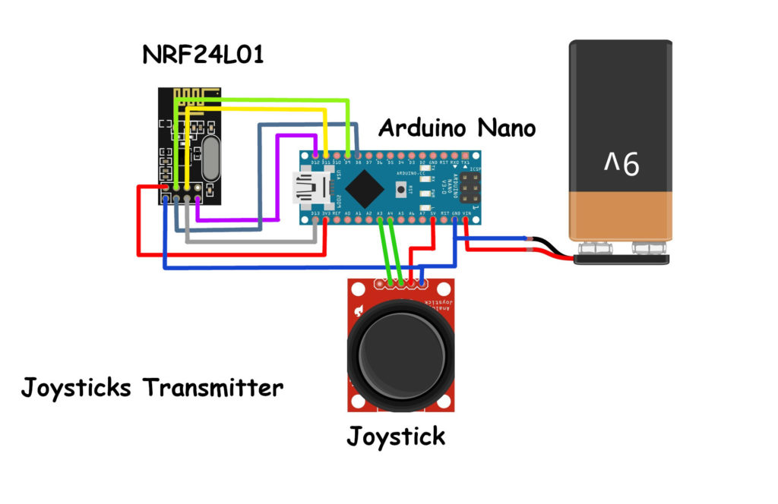

Receiver :

